

**Touchstones**

***Netcards***

**Good & Evil Netcards with Text**

Battleground HRJ

Beautiful HRJ

Beyond HRJ

Blur HRJ

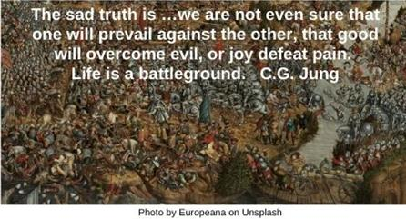



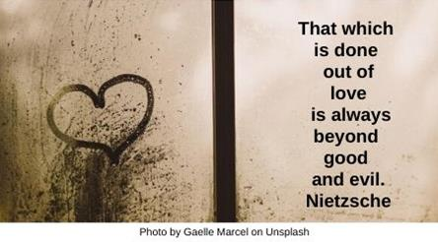

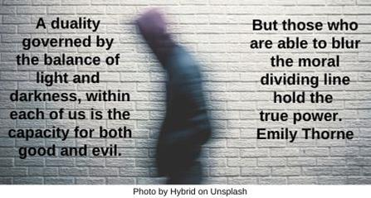

Bread HRJ

Buddha HRJ

Choice HRJ

Coin HRJ

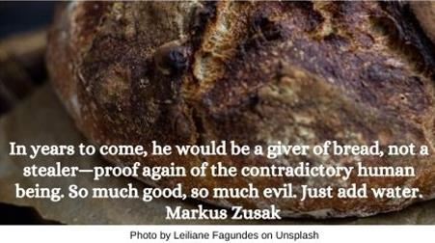

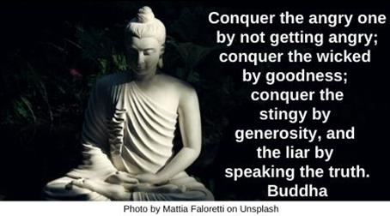

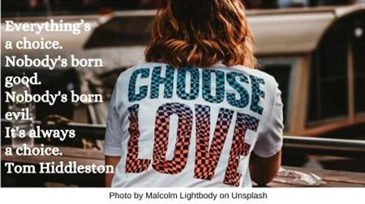

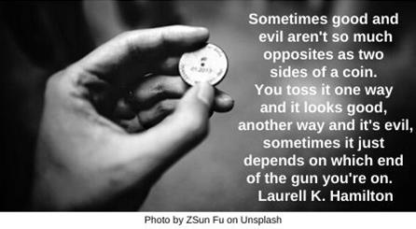

Compound Interest HRJ

Crucible HRJ

Dangerous HRJ

Disorienting HRJ

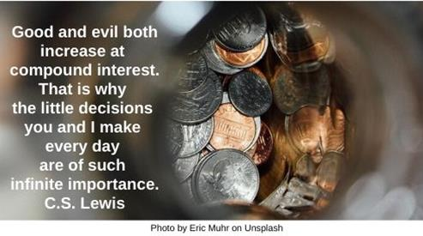

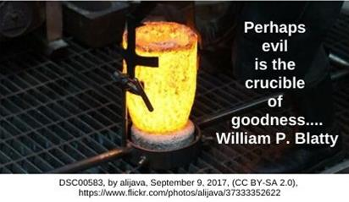

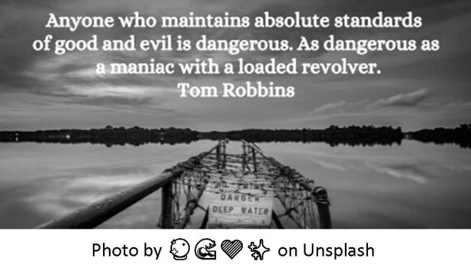

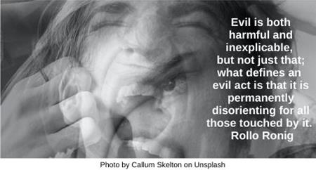

Dragon HRJ

Good Places HRJ

Investment HRJ

Look HRJ

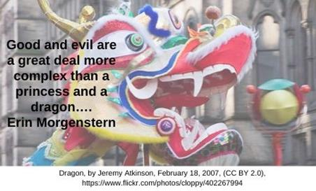

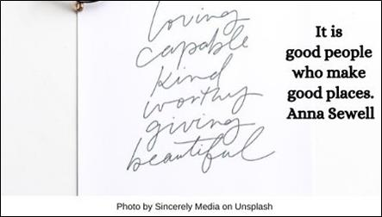

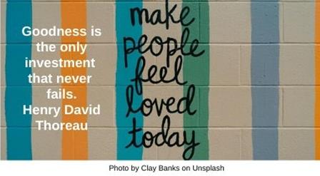

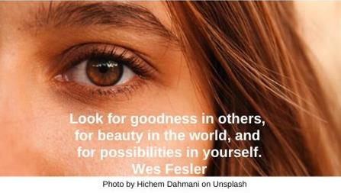

Love and Truth HRJ

No Understanding HRJ

Other World HRJ

Our Choice HRJ

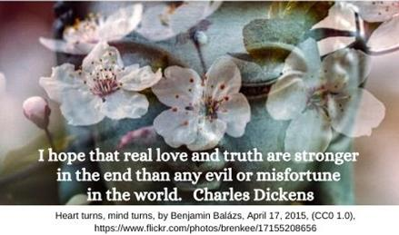

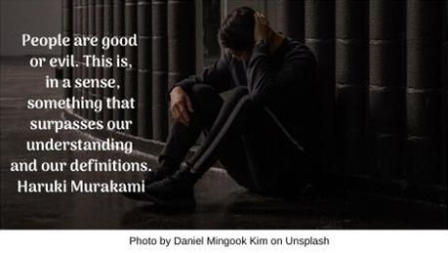

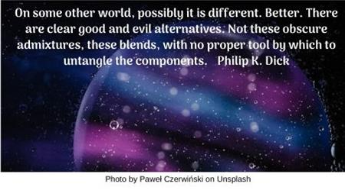

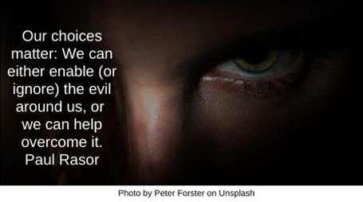

Permeable HRJ

Pyramid HRJ

Question HRJ

Scream HRJ

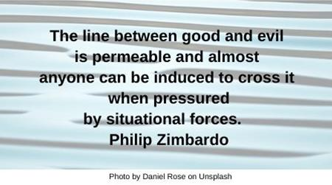



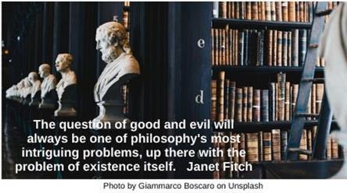

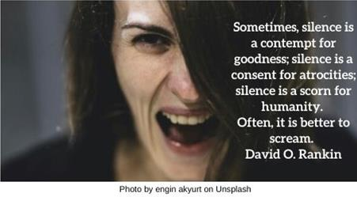

The Line HRJ

Thirst HRJ

Two Paths HRJ

Wisdom HRJ

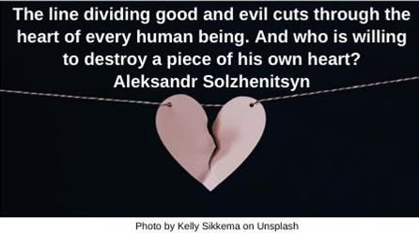

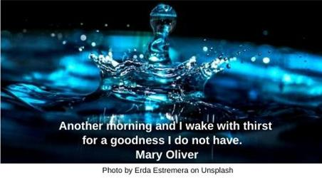

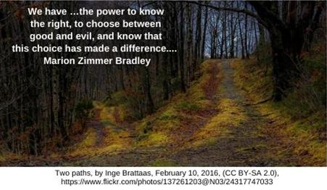

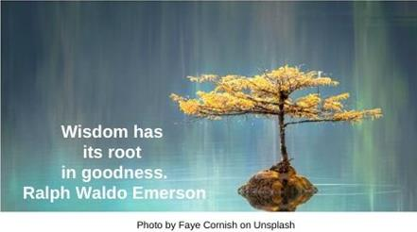

Within the Soul HRJ

Words HRJ

Yin Yang HRJ

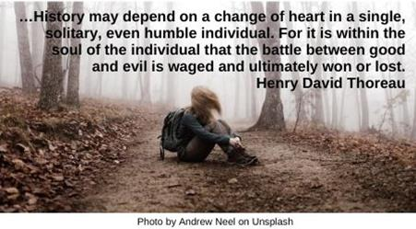

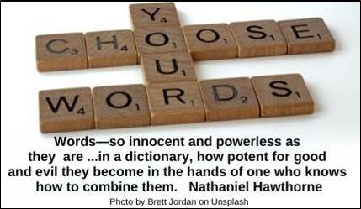

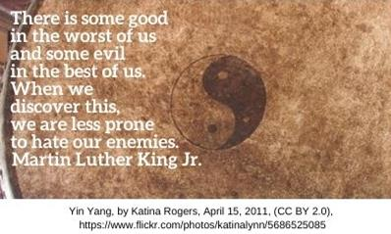

**Text of Quotes**

Battleground

The sad truth is …we are not even sure that one will prevail against the other, that good will overcome evil, or joy defeat pain. Life is a battleground. C.G. Jung

Beautiful

Life becomes easier and more beautiful when we can see the good in other people. Roy Bennett

Beyond

That which is done out of love is always beyond good and evil. Nietzsche

Blur

A duality governed by the balance of light and darkness, within each of us is the capacity for both good and evil. But those who are able to blur the moral dividing line hold the true power. Emily Thorne

Bread

In years to come, he would be a giver of bread, not a stealer—proof again of the contradictory human being. So much good, so much evil. Just add water. Markus Zusak

Buddha

Conquer the angry one by not getting angry; conquer the wicked by goodness; conquer the stingy by generosity, and the liar by speaking the truth. Buddha

Choice

Everything’s a choice. Nobody's born good. Nobody's born evil. It's always a choice. Tom Hiddleston

Coin

Sometimes good and evil aren't so much opposites as two sides of a coin. You toss it one way and it looks good, another way and it's evil, sometimes it just depends on which end of the gun you're on. Laurell K. Hamilton

Compound Interest

Good and evil both increase at compound interest. That is why the little decisions you and I make every day are of such infinite importance. C.S. Lewis

Crucible

Perhaps evil is the crucible of goodness... William Peter Blatty

Dangerous

Anyone who maintains absolute standards of good and evil is dangerous. As dangerous as a maniac with a loaded revolver. Tom Robbins

Disorienting

Evil is both harmful and inexplicable, but not just that; what defines an evil act is that it is permanently disorienting for all those touched by it. Rollo Ronig

Dragon

Good and evil are a great deal more complex than a princess and a dragon…. Erin Morgenstern

Good Places

It is good people who make good places. Anna Sewell

Investment

Goodness is the only investment that never fails. Henry David Thoreau

Look

Look for goodness in others, for beauty in the world, and for possibilities in yourself. Wes Fesler

Love and Truth

I hope that real love and truth are stronger in the end than any evil or misfortune in the world. Charles Dickens

No Understanding

…People are good or evil. This is, in a sense, something that surpasses our understanding and our definitions.

Haruki Murakami

Other World

On some other world, possibly it is different. Better. There are clear good and evil alternatives. Not these obscure admixtures, these blends, with no proper tool by which to untangle the components. Philip K. Dick

Our Choice

Our choices matter: We can either enable (or ignore) the evil around us, or we can help overcome it. Paul Rasor

Permeable

The line between good and evil is permeable and almost anyone can be induced to cross it when pressured by situational forces. Philip Zimbardo

Pyramid

Throughout our nervous history, we have constructed pyramidic towers of evil, ofttimes in the name of good. Maya Angelou

Question

The question of good and evil will always be one of philosophy's most intriguing problems, up there with the problem of existence itself. Janet Fitch

Scream

Sometimes, silence is a contempt for goodness; silence is a consent for atrocities; silence is a scorn for humanity. Often, it is better to scream. David O. Rankin

The Line

The line dividing good and evil cuts through the heart of every human being. And who is willing to destroy a piece of his own heart?” Aleksandr Solzhenitsyn

Thirst

Another morning and I wake with thirst for a goodness I do not have. Mary Oliver

Two Paths

We have …the power to know the right, to choose between good and evil, and know that this choice has made a difference.... Marion Zimmer Bradley

Wisdom

Wisdom has its root in goodness. Ralph Waldo Emerson

Within the Soul

…History may depend on a change of heart in a single, solitary, even humble individual. For it is within the soul of the individual that the battle between good and evil is waged and ultimately won or lost. Henry David Thoreau

Words

Words—so innocent and powerless as they are, as standing in a dictionary, how potent for good and evil they become in the hands of one who knows how to combine them. Nathaniel Hawthorne

Yin Yang

There is some good in the worst of us and some evil in the best of us. When we discover this, we are less prone to hate our enemies. Martin Luther King Jr.